ELECTRIC ECONOMICS SIMULATOR TUTORIAL
IN DEVELOPMENT V:1.0A

INTRODUCTION
You have probably heard of the “electric grid”, and you likely have some idea that it is where the electricity comes from. This is true, in a more accurate sense the “grid” describes the network of everything that moves, consumes, and produces electricity. It is produced by generators of various forms and then distributed to consumers (in a modern economy, this includes most stationary machinery). A peculiarity of this system is that the amount of electricity being fed into it must be exactly equivalent to the amount being drawn out of it at any given time, or technological chaos ensues. Another peculiarity of this system is that all electricity is essentially identical, there is essentially no way to differentiate one business’s service from another except cost, assuming both are able to provide reliable service, (which is considered absolutely mandatory). For this reason, the entire electric industry is trying to find a mix of generators which is:
A: Able to match supply with demand under all foreseeable conditions
B: Less costly than everything else.
This is a more complex and interesting problem than it seems at first glance.

Units
The basic unit used in this context is the “watt”, usually with kilo (1000 watts), or giga (1 billion watts) suffixes. This measures a continuous flow of energy (this lightbulb consumes 100 watts of electricity to stay running). The watt-hour measures total energy and is usually how electricity is priced. Things like the size of a power plant or current demand for electricity are measured in watts. The amount of power you can store in a battery or total amount of electricity used in a given month is measured in “watt-hours”.

In the simulator, you will most often be working in gigawatts (1 billion watts), however the calculated cost will be presented to you in cents per kilowatt hour.

Example:
A 100 watt (0.1 KW) lightbulb runs for 20 hours. 0.1 * 10 => It consumed 2 KWH of electricity.
If electricity costs 0.06 cents per kilowatt hour, then running the lightbulb for 20 hours costs
(6 cents * 2 Kilowatt hours (KWH)) = 12 cents.

What is “Cost”?
It needs little explaining that “cost” includes fuel, maintenance, construction, etc. However, defining “cost” is more complicated than simply tabulating all business expenses. Power plants are extremely expensive projects which loans must be taken out for, which are then paid off over decades. Financing costs are extremely important to any discussion of cost, oftentimes for renewable or nuclear energy projects interest payments can be the largest expense of them all. Additionally, these days the environmental impact of carbon emissions is an important consideration when evaluating power projects. In this simulator, the environmental cost of carbon emissions is assumed to have a dollar value.

Due to these assumptions,costs will be derived from the user-selected dataset for construction and maintenance costs, a user-selected interest rate (suggested values: 3%, 5%, 7%), a user-selected carbon penalty (suggested values: $0, $60, $180, $300), fuel costs, and an evaluation period of 40 or 80 years. For the sake of simplicity, all construction costs are paid for by a single loan paid off over the selected evaluation period.

In real life, these factors and more determine what set of generators provides the best value.

THE SIMULATION

The simulation computes all things hourly, to 8760 hours so that each evaluation is over about a year. Financial costs are calculated separately, and just assume an identical year 40 or 80 times, this has no bearing on the simulation.

At each hour, 3 independent variables are considered

Demand
Sunsine
Wind
And an assortment of values provided by the user using the sliders.
Demand Sunshine and Wind are taken from the data files for a given region. They represent the natural variations in wind, sunshine, and electricity demand.
All supply and demand is scaled, so that a power of 1 corresponds to the maximum demand seen over the entire period of 8760 hours. Sunshine and Wind represent what fraction of full power wind and solar power capacity will run at. Individual power plants are not considered, due to the interconnected and instantaneous nature of power grids, all demand and generation can be approximated as a single wattage value. A generation fleet of capacity “1” has a wattage equivalent to the highest demand. Right now, a power of “1” is assumed to be equal to 40 gigawatts, however this could easily be changed to represent the actual peak demand for any given region. From a software perspective, the peak demand value is purely cosmetic.

Each time a slider is adjusted, the simulation will be re-run with the updated values (usually a given quantity of capacity for a generation type). All types of capacity are added by the user, except for gas turbines. Gas turbine capacity is automatically dispatched whenever there is a shortfall of other generation. The highest gas turbine dispatch is assumed to be how many gas turbines were built by the financial calculations.

Gas turbine generation is also terminated if there is a supply of stored energy making up for a deficit. Generators can charge energy storage if supply exceeds demand. Primary storage (intended to model batteries and pumped hydro) will completely disable all gas turbines when it is more than 0, and gas turbines will jump in to completely fill the deficit when it depletes. Combined cycles (Steam), coal capacity, and thermal storage/hydrogen have far more complex and which will be explained shortly.

For the most part, nuclear, wind, and solar are considered to be the invariable generators. Nuclear always runs at 100%, while wind and solar always run at whatever percentage is dictated by the “Sunshine” and “Wind” variables. For this reason, the sum of these almost never perfectly matches demand. Maybe some pictures will make this easier to visualize.

First step: I have built no power plants. 100% of demand is met by the automatic gas turbines
Notice how the dark blue “gas turbine” line directly tracks the red demand line.
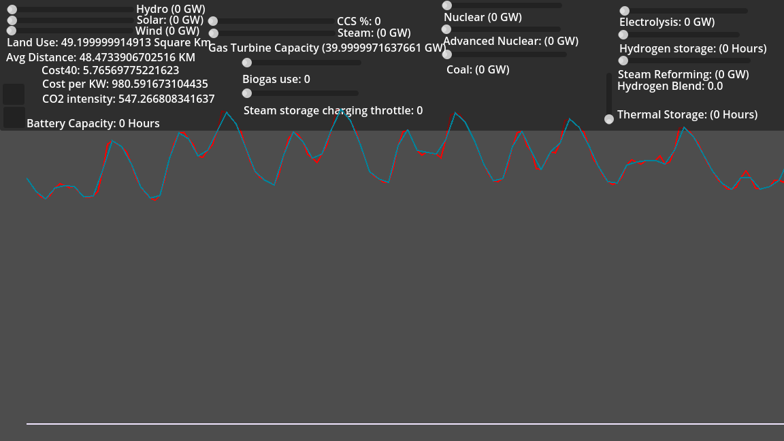

Next, I add some nuclear power capacity. Nuclear plants can be approximated as running at full power at all times.
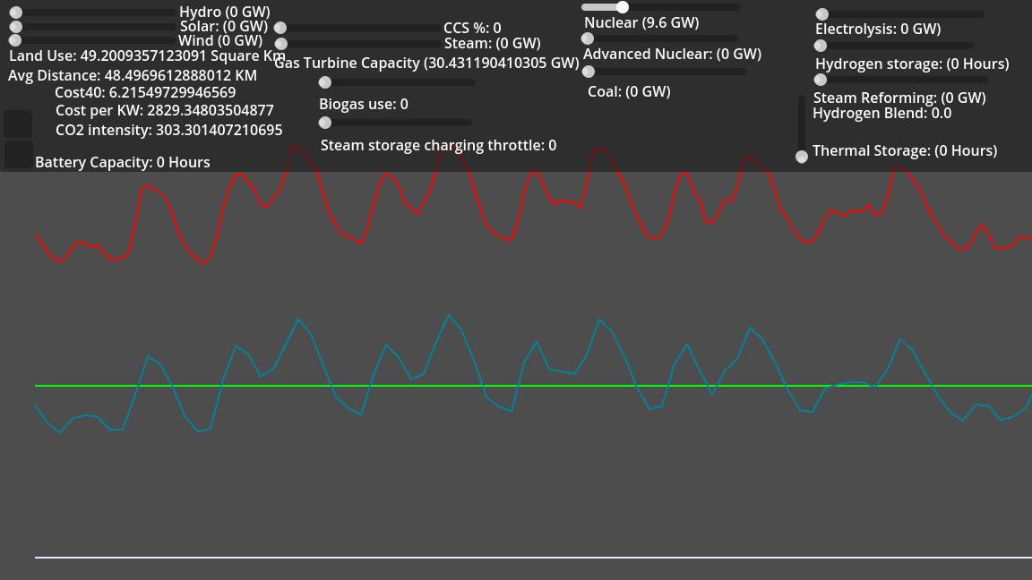
Notice how the gas output still tracks the demand, but it has nuclear output subtracted from it. Gas turbine has dropped to 30 GW, because when demand reaches its peak of 40 GW there are about 10 GW of nuclear plants available to help keep up.

Next, let's add some solar power. The sum of all nuclear, solar, and wind is shown by the bright green line.
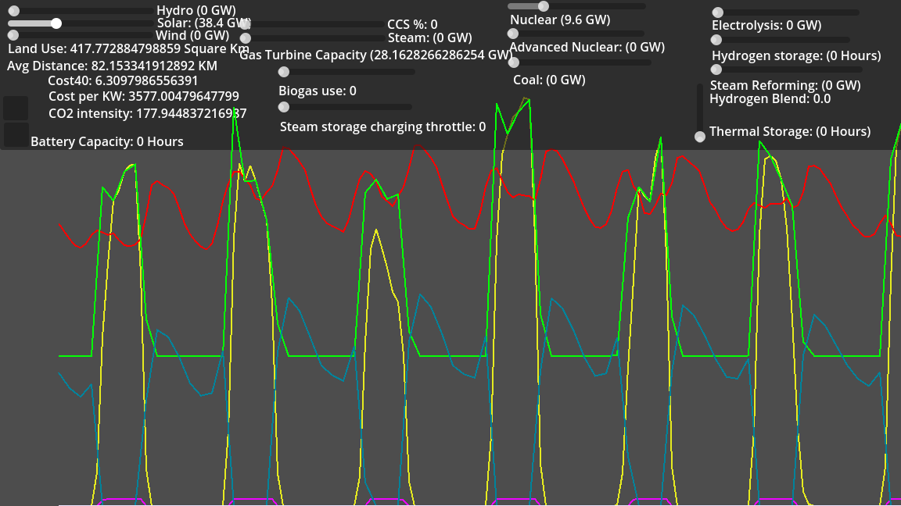
Here, we see jumps in power when the sun is out and the solar power can run. During thes periods, the gas turbines turn off, saving fuel. The green like may appear to track demand, this is because the nuclear plants can limit their output to some extent if there is no way to store their energy. Since this saves a tiny amount of uranium fuel cost, the simulator does not consider this wasted and the bright green line reflects this. If the nuclear power plants were unable to throttle, the green line would exactly match the yellow solar line with no tracking of demand.

Also, gas turbine capacity has dropped to 28 GW because apparently when the simulation reaches peak demand, there are about 2 GW of solar power available. (Presumably this is occurring during the evening when the sun is not out fully).

Next, some batteries are added to take advantage of this surplus clean energy.

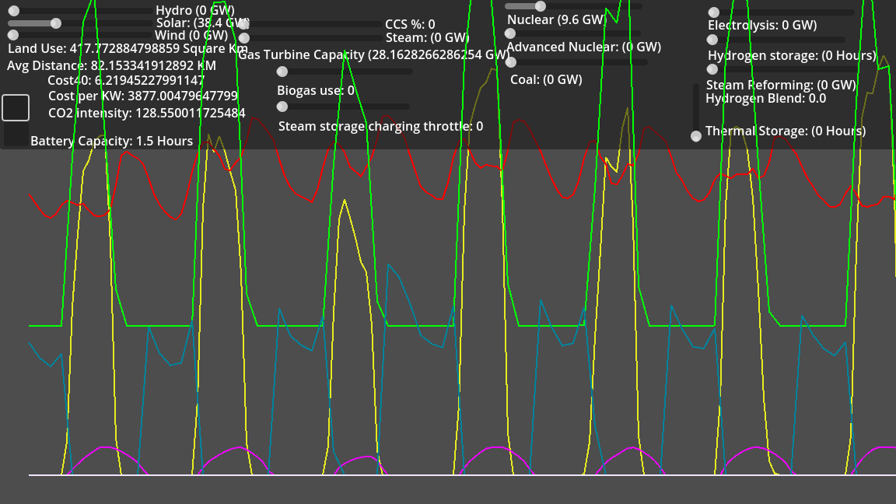
You can see here that solar and nuclear power (green line) charge the batteries when they exceed demand, the gas turbines start back up at around the same time that the batteries run dry. The batteries can then use this surplus energy to shrink the amount of time that gas turbines need to run. Despite this, we still have 28 GW of gas turbines as when we had no batteries. This is because whenever demand reached its peak of 40 GW in the simulation, batteries had already been depleted and thus the situation necessitated the same amount of gas turbines to satisfy.

Higher level features of the simulator are explained in manual.docx

